1. Source code

v_footer.php > application/views

v_header.php > application/views

v_index.php > application/views

v_about.php > application/views

stylebuku.css > assets/css

Web.php > application/controllers

1. URL

<http://localhost/pustakabooking/web>

http://localhost/pustakabooking/index.php/web/about

1. Capture Output Program

* Tampilan web

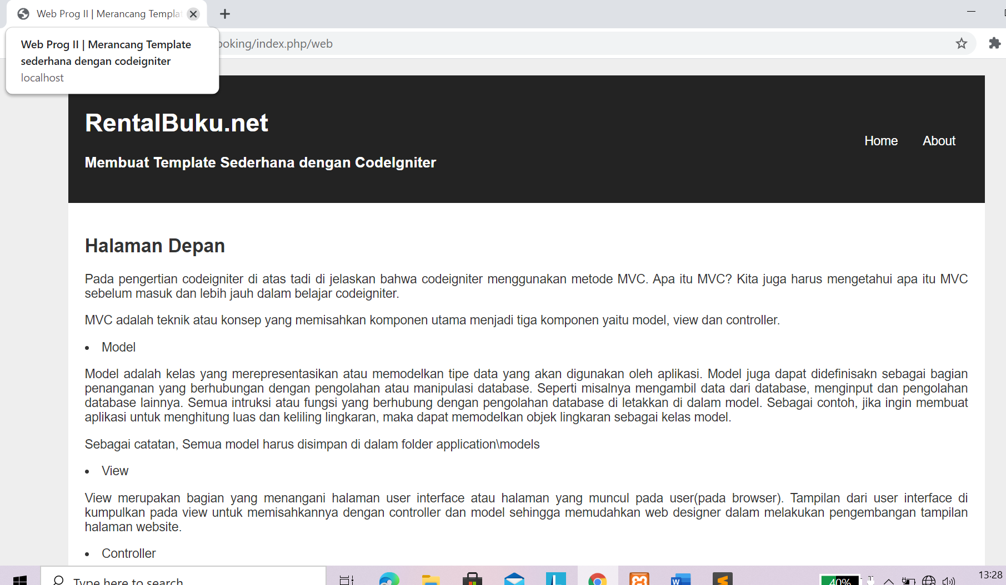

* Tampilan about

